Vehicle Insurance

This unit is intended to introduce young people to important areas of road safety which will be of value to them throughout their lives. This unit is a self-contained resource covering the topic of Vehicle Insurance and the Law relating to insurance.
The somewhat complex nature of insurance makes it an area not easily grasped by young people and it is sometimes unfortunately ignored, the consequences of which can be disastrous for the individual concerned.

This unit aims to make young people aware of the process of obtaining Vehicle Insurance and how it is an important part of becoming a driver and vehicle owner.

• Understand the Legal requirement in respect of Vehicle Insurance
• Know where, and how to obtain insurance quotation.
• Understand the consequences of not obeying the rules.

This Unit is aimed at a 35 – 40 minute lesson. The teacher can use the task sheets as a follow up to the power point presentation as and when required. We have included a suggested time for each task, but this is purely a guideline.

The following resources are intended to help you to deliver this Unit:

• Baseline evaluation (5mins) (ANNEX A)
• Power point presentation/discussion (20 mins)
• Task sheets (5 mins per task sheet)
• Post evaluation (5 mins) (ANNEX B)

Sample Answers to Task Sheets

Task Sheet 1

Third Party | Third Party, Fire & Theft | Comprehensive

- Involved in a collision resulting in serious injury or death to another person.

- Your vehicle has been stolen and burnt out.

- Damage to your car from wear and tear.

- Damaging other people’s property such as damaging a fence.

- Driving your parents car or a friend’s car

- An attempted theft of your car resulted in damage to the cars bodywork

Task Sheet 2

Possible answers  include:  1. | on-line;  visit insurance broker; and  telephone.
2. | Increase excess;  Lower annual mileage;  Lower car insurance group;  Lower engine cylinder capacity;  black box fitted;  remove modifications;  park in locked garage at night if available; and  where you live.
3. | It is a legal requirement- Road Traffic Act 1988;  Required for taxing your vehicle;  Protects you, your vehicle and other motorists against liability in the event of a collision; and  Compensation to cover any injuries caused to people or their property.
4. | Max fine £5000;  Added 6-8 penalty points;  Harsher sentences exist for people who injure or kill someone while driving with no insurance;  Vehicle may be seized; and  Vehicle may be seized and crushed.
5. | Driver’s name;  Driver’s address;  Name and address of vehicle owner (if different from above)  Telephone numbers; and  Vehicle registration number.

Task Sheet 3

Task Sheet 4
The figures below were obtained from moneysupermarket.com- NI costs may be higher.
You may wish to put the details of a different vehicle into the website to make it appropriate to your students.
- What would the cost of his insurance be if he parked it in his drive at night instead of in a locked garage?
£2635.00 (an increase of £130)

- What would the cost of his insurance be if he had 3 penalty points and a £90 fine for a speeding offence?

£2974.00 (an increase of £469)

- What would the cost of his insurance be if he modified his vehicle by adding a rear spoiler, body kit, alloy wheels, wider tyres and lowered the car suspension?

£4312.00 (an increase of £1807)
- What would the cost of his insurance be if he parked his car in the drive at night, had 3 penalty points and a £90 fine for a speeding offence and modified his vehicle by adding a rear spoiler, body kit, alloy wheels, wider tyres and lowered the car suspension?
£5392.00 (an increase of £2887)

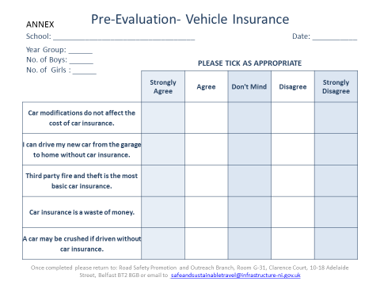
Annex A
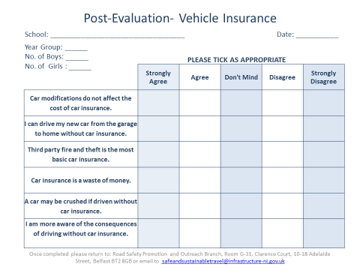
Annex B

