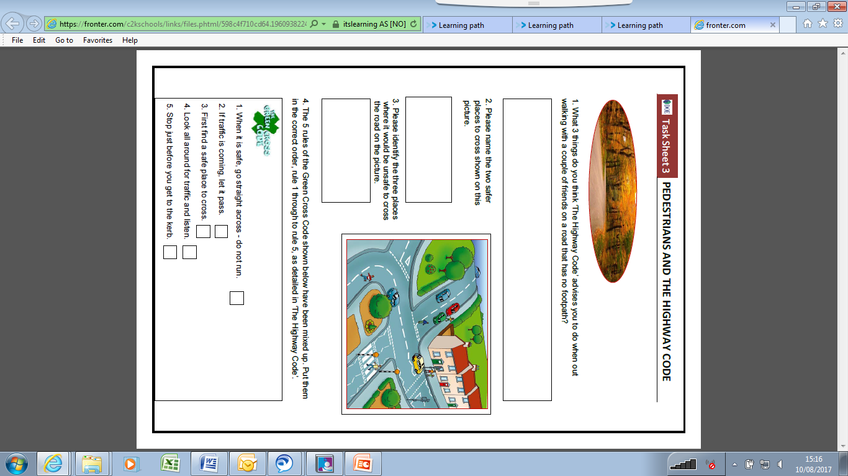

**Task Sheet 3 – Pedestrians & Highway Code**