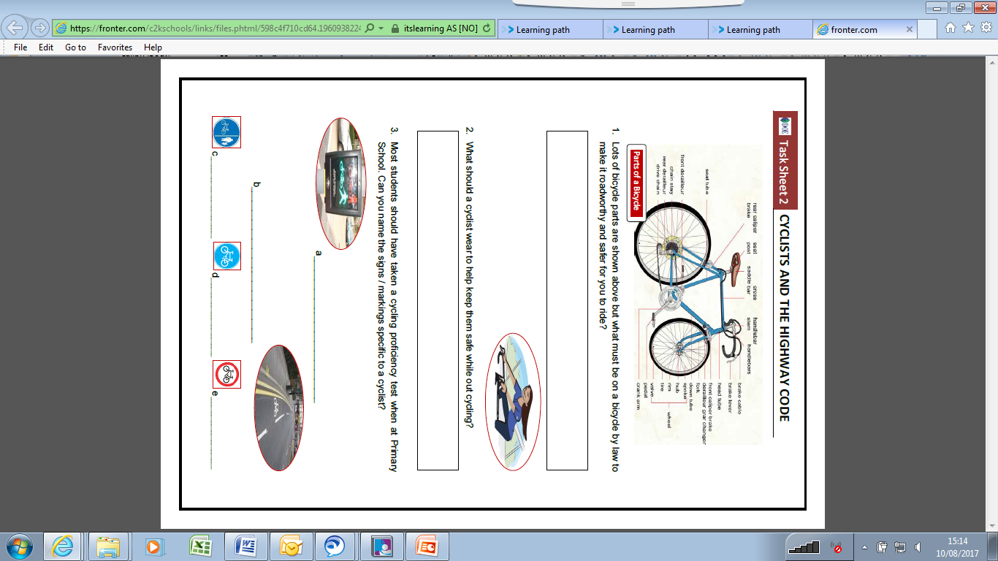

**Task Sheet 2 – Cyclists & Highway Code**