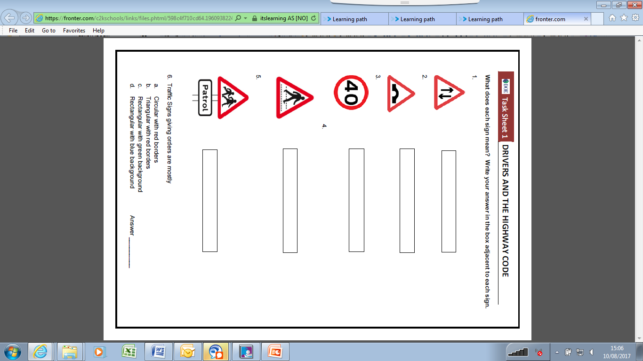

**Task Sheet 1 – Drivers & Highway Code**