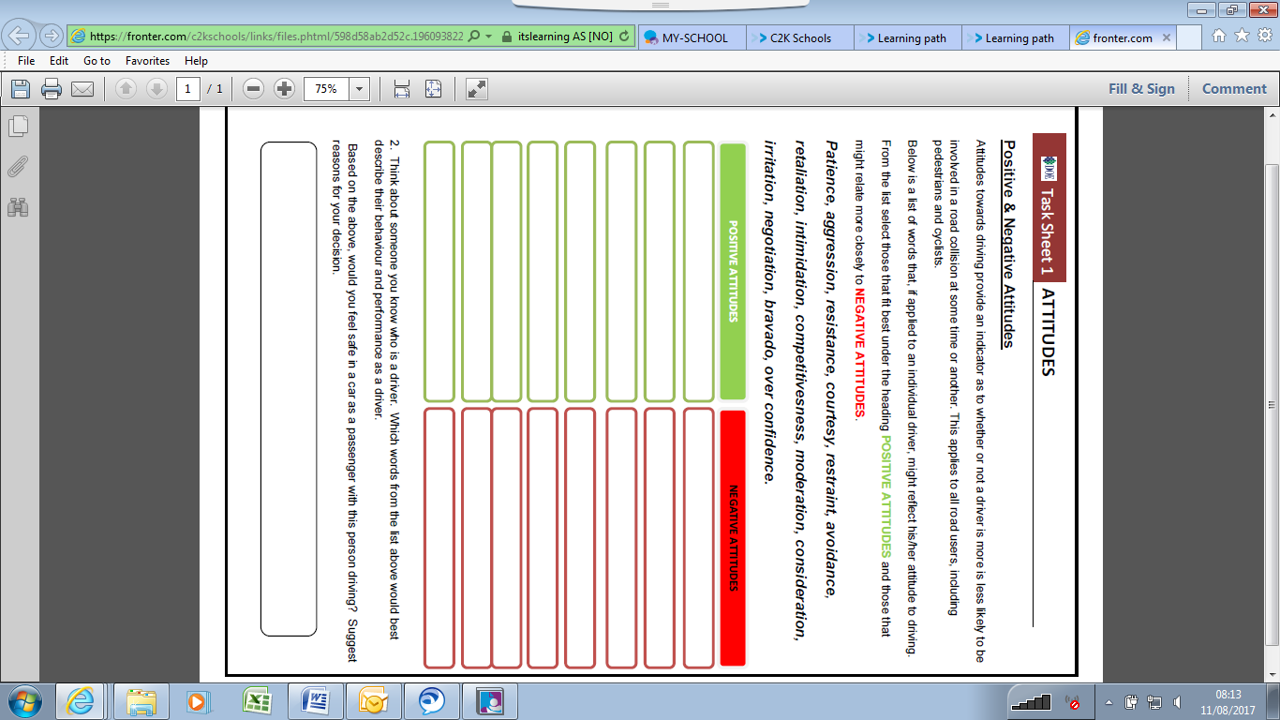

**Task Sheet 1 – Attitudes**