**Teacher Notes - Seat Belts**

**The Human Collision**

Imagine running as fast as you can - into a wall. Do you think you could stop yourself if the wall suddenly loomed up when you were two feet away from it? This is exactly the situation you face when the front of your car hits something at only 15 miles an hour. The car stops in the first tenth of a second, but you keep on at the same rate you were going in the car until something stops you - the steering wheel, dashboard or windshield - if you're not wearing your seat belt. Bad enough at 15 miles an hour, but at 30 miles per hour you hit "the wall" four times as hard as you would at 15. Or to put it another way, with the same impact you'd feel as if you fell three stories.

**A properly worn safety belt keeps that second collision - the human collision - from happening.**

This unit is a self-contained resource covering the topic of ‘Seat Belts ‘ and looks at the importance of wearing a seatbelt correctly, using the appropriate seat according to the age and height of the person and how this will reduce the serious injuries or death to passengers and drivers.

This Unit is aimed at a 35 – 40 minute lesson. The teacher can use the task sheets as a follow up to the power point presentation as and when required. We have included a suggested time for each task, but this is purely a guideline.

The following resources are intended to help you to deliver this Unit:

• Baseline evaluation (5mins) (ANNEX A)

• Power point presentation/discussion (20 mins)

• Task sheets (5 mins per task sheet)

• Post evaluation (5 mins) (ANNEX B)

**Answers to Tasksheets**

**Task Sheet 1**

**1. In a severe collision, you have a better chance of surviving if you are not wearing a seat belt and are thrown from the car.**

A. True B. **False**

Studies show that many crash victims who did not wear a seat belt and were killed after being thrown out of the car would have lived—often with only minor injuries—if they had been restrained within the car.

**2. Children over 13 are responsible for wearing their own seatbelt.**

A. True B. **False**

The driver is responsible for any passenger under 14 years of age wearing a seatbelt in their car.

**3. The law on seat belt wearing in the front seat came into force in January 1983.**

A. **True** B. False

This legislation came into force on 31st Jan 1983.

**4. If your car has an air bag, you don't need to wear a seat belt.**

A. True B. **False**

An air bag is a supplemental restraint only. For it to work properly, you must wear your seat belt. Many air bags inflate in head-on crashes, and some vehicles now have air bags for side impacts. Seat belts, on the other hand, can protect you in every type of collision.

**5. Never buckle a child safety seat into the front seat of a car that has an air bag.**

A. True B. **False**

In a crash, an air bag inflates instantly at up to 200 mph and can slam into the back of a rear-facing infant seat (where the baby's head rests) or into the upper body of an older child in a forward-facing safety seat. The safest place for a child 12 and under is in the backseat.

**6. If an adult is not wearing a seat belt and is sitting too close to the dashboard, he or she could be in danger if the air bag inflates.**

A. **True** B. False

Unbuckled passengers of all ages can be injured or killed by an inflating air bag. Adults and teens riding in the front seat should buckle up and sit at least 10 inches away from the dashboard. Kids 12 years and younger should ride buckled up in the backseat.

**7. Seat belts and child safety seats are necessary only for long-distance driving or for travelling at fast speeds.**

A. True B. **False**

Most crashes occur at speeds under 40 mph and within 25 miles of home.

**8. The instruction booklet for a child safety seat tells you everything you need to know about installing the seat safely in your vehicle.**

A. True B. **False**

To install the seat safely in your car, read both the safety seat manual and your car's owner's manual. Depending on your vehicle, you may need a supplemental belt, metal locking clip, or other device for a snug fit.

**9. Once a child weighs 18kg, he or she can ride safely in a car with a regular seat belt.**

1. True B. **False**

Children who weigh between 18kg and 27kg are safest when riding in a booster seat and secured by a lap and shoulder belt. The booster seat elevates the child so that the belt fits across the body properly and snugly, which maximizes protection.

**10. If your car doesn't have an air bag, a child can ride safely in the front seat.**

A. True B. **False**

Air bag or not, the backseat is still the safest place for children of any age to ride.

**Task Sheet 2**

|  |  |  |
| --- | --- | --- |
| **1.WITH SEATBELT** | 1. Highlight with an “**X”** which parts of the body could be damaged by wearing a seatbelt.     2. Highlight with an “**O”** which parts of the body could be damaged by NOT wearing a seatbelt.  | **2. NO SEAT BELT** |

**Some injuries that may occur as a result of wearing a seatbelt** include fractured sternum, shoulder tendon sprain, shoulder joint sprain caused by the separation of the clavicle and shoulder, broken collar bone.

**Without the seatbelt the injuries would be more severe** including, brain damage and or neck injury – head hitting windscreen/window pillar; brain swollen and possible stroke from interruption of blood flow to the brain; possible paralysis and lose of control of bodily functions; multiple rib fractures that may puncture lungs and liver; heart and lungs damaged by hitting steering wheel; fractured hip joints caused by knees hitting dash – difficulty walking unaided. Some of these injuries will result in the death of the person involved in the crash.

**3. In what year was the wearing of seatbelts in the back seat made compulsory?**

1991

**4. You didn’t wear a seatbelt when in a car crash and you would have had no injuries had you been wearing one – your compensation claim will be reduced by what %?**

25%

**5. How many penalty points do you receive if caught not wearing a seatbelt?**

3 points

**6. At what age/height do you change from a booster seat to seatbelt?**

12/135cms

**7. Wearing you seatbelt reduces your chance of injury by what %?**

About 50%

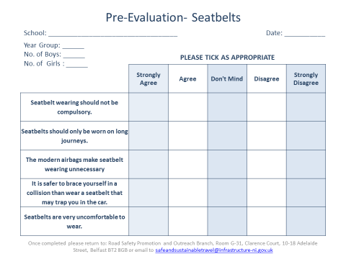

Annex A

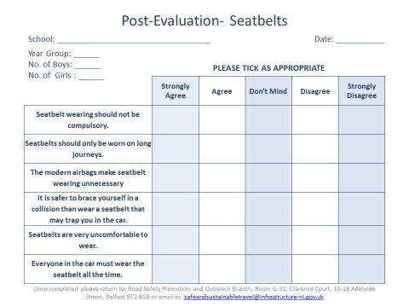

Annex B