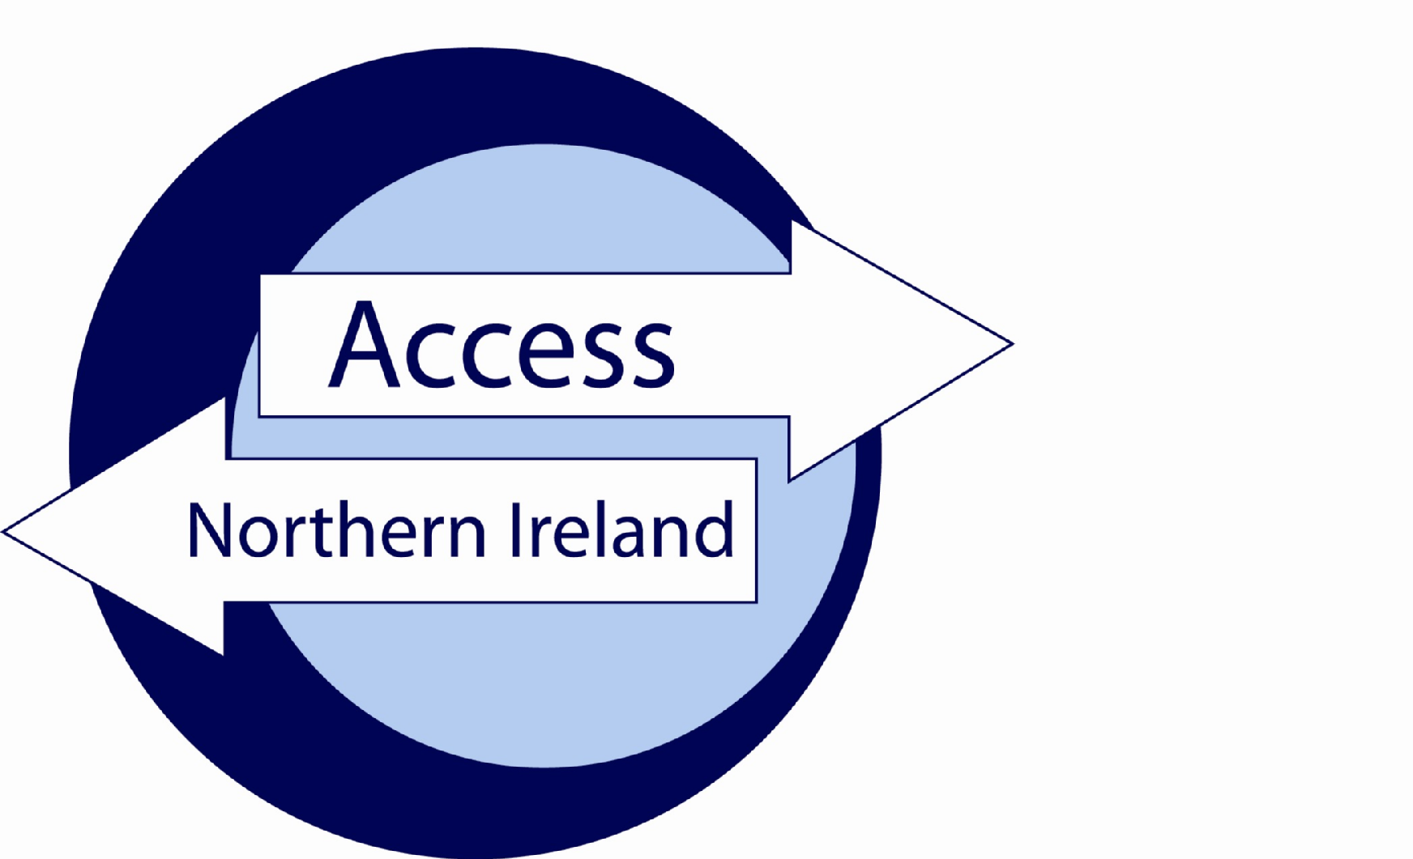

Service Level Agreement

Between

[Umbrella Body name]
(Responsible Body)
to process Basic Disclosure checks

and

[3rd Party]

Date [mm-yy]
Index

Page

Section 1 – The Agreement 3
Introduction 3
Background 3
Scope 3
Assumptions 3
Section 2 – Roles & Responsibilities 5
Annexe A…………………………………………………………………………………………………………...8
Annexe B………………………………………………………………………………………………………….11
Annexe C………………………………………………………………………………………………………….12

Section 1 – The Agreement

Introduction
The purpose of this agreement between [Umbrella Body Name] and [3rd Party Name] is to set out the terms under which both parties will agree to comply when handling personal information during the AccessNI disclosure process.

This agreement is made on [insert date] and will commence at the same time.

Unless the Agreement is specifically amended, altered or withdrawn it will be automatically agreed to have rolled over on the 1st April each year.

Background
Umbrella Bodies cannot take a recruitment decision on the basis of information contained on a Disclosure Certificate unless the applicant will be directly working for the Umbrella Body. This Agreement recognises that AccessNI provides one copy only of a Disclosure Certificate to the applicant. However, the on-line case tracking system enables [Umbrella Body name] to know when a Disclosure Certificate has been issued and whether there is any information in that Certificate. [Umbrella Body name] will provide relevant information to [3rd party name]. [Umbrella Body name] will record details that their part of the process is complete.

Scope
The terms of this agreement shall not be varied or amended unless agreed to and confirmed in writing by authorised representatives of [Umbrella Body Name] and [3rd Party Name] or AccessNI. AccessNI may, given appropriate notice, withdraw an organisations designation of Umbrella Body or request they do not offer their service to 3rd parties.

Assumptions
This agreement is based on the following assumptions:

- An employer / organisation has approached the Umbrella Body to assist with the processing of an AccessNI disclosure application;
- The employer / organisation requires Basic disclosures for individuals who they may seek to recruit;Umbrella Body / employer will only submit applications to AccessNI using the on-line portal on the NI Direct website;
- If a charge is applicable for the Disclosure, both parties to this SLA will have agreed the means by which payment will be made, prior to submitting a disclosure to AccessNI;
- It is understood that AccessNI will only issue an invoice to the Umbrella Body;
- That the information supplied in Disclosure Application Forms is correct.

Section 2 – Roles & Responsibilities

Umbrella Body Name will;
- assist [3rd Party Name] through the AccessNI Disclosure process, including providing the appropriate personal identification number (PIN) for applicants to enable them to use the on-line application process;
- ensure Disclosure Applications are countersigned properly;
- verify the Identification of applicants per AccessNI guidance, or ensure the ID validation form is completed by [3rd Party Name];
- retain the ID validation form (if applicable) and a copy of the ID documentation for at least 90 days after the disclosure certificate has issued;
- be first point of contact with AccessNI on matters relating to Disclosure Applications submitted through them;
- gather any additional information AccessNI request by either directly contacting [3rd Party Name] or the applicant;
- notify [3rd Party Name] that
  - a Disclosure Certificate has been issued by AccessNI; and
  - there is no information on the Disclosure Certificate; or
  - information has been disclosed on the Disclosure Certificate. Where information has been disclosed the Umbrella Body should advise the employer to ask the applicant to provide that employer with their copy of the Disclosure Certificate in order to view the information and progress to the next stage of the recruitment process.
- advise the employer/organisation to ensure that on sight of a Disclosure Certificate containing information they handle such information in line with the AccessNI Service Level Agreement and the Data Protection Act 2018;
- provide [3rd Party Name] with guidance on secure handling and storage of information;
- provide [3rd Party Name] with guidance on the recruitment of ex-offenders.
- provide [3rd Party Name] with a copy of the AccessNI Privacy Notice or provide a link (https://www.justice-ni.gov.uk/publications/ani-privacy).
- monitor [3rd Party name] is complying with the Service Level Agreement.

[3rd Party Name] will;

- ensure that the appropriate PIN number is supplied to the applicant to complete the on-line application form;
- undertake the appropriate identity checks on applicants, using the methodology in Annex A and complete the PIN Notification and ID Validation Form, (also found on the Employers section of the AccessNI website, www.nidirect.gov.uk/accessni) unless agreed with the Umbrella Body this will form part to the service they provide;
- undertake the appropriate identity checks on applicants, using the methodology in Annex A and complete the PIN Notification and ID Validation Form, also found on the Application Form section of the AccessNI website, www.nidirect.gov.uk/accessni– unless agreed with the Umbrella Body this will form part of the service they provide;
- if appropriate, pass the PIN Notification and ID Validation form to [Umbrella Body Name] along with a copy of the ID documents;
- agree that only staff authorised by [Umbrella Body Name] will undertake the checking of Applicants identification documents;
- In as many cases as possible, check identification documents in the presence of the person concerned;
- comply with provisions set out in this Service Level Agreement; ensure the information on Disclosure Certificates provided by applicants is retained in a secure manner, accessible only by those with authority to see them. Details of non-court convictions, convictions, police information or barred list information should not be retained after the recruitment decision is made;
- Ensure that the subject of a disclosure is aware that a Basic check (or re-check) is required for a position in the organisation.
- Retain signed documentary evidence (for the duration of the employment) that an applicant has agreed to undertake a Basic check;
- Obtain written permission from the individual applying for a Basic Disclosure if the certificate is to be delivered to the address of [Name of Organisation]. Without such permission the Responsible/Umbrella Body will be in breach of the Data Protection Act (DPA) 2018;
- Have a written policy on the suitability of ex-offenders for employment in relevant positions that should not unfairly discriminate on the basis of conviction or other information disclosed. This policy should be available upon request to potential applicants and, in the case of those carrying out an umbrella function, should be made available to their clients.
- ensure that Disclosure information is not passed to persons not authorised to receive it;
- Either return original Disclosure Certificate to the Applicant or agree with the Applicant (in writing) the period for which the organisation will retain the original Certificate;
- Ensure that Disclosure information is not passed to persons not authorised to receive it;
- Ensure that Disclosure information is only made available to those who need to have access in the course of their duties;
- have a policy on the Secure Handling, Use, Storage and Retention of Disclosure information. This policy should be available upon request to potential applicants and, in the case of those carrying out an umbrella function, should be made available to their clients.
- If a paper application is being completed by the applicant provide the applicant with a copy of the AccessNI Privacy Notice or provide a link (https://www.justice-ni.gov.uk/publications/ani-privacy) to this document in your recruitment material.
- comply with recommendations made by the Umbrella Body.

Section 3 – Authorisation and Agreement

The Services detailed in this Agreement have been authorised and agreed by the following parties

PART A

For [Umbrella Body Name]

Signed

Name

Position

Date

PART B

For [Name of 3rd Party]

Signed

Name

Position

Date

Annex A
PIN NOTIFICATION AND ID VALIDATION FORM | 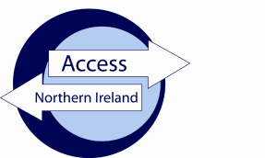

Applicant instructions

- Go to www.nidirect.gov.uk/apply-for-a-basic-check-through-a-responsible-body

- Select the green button to create a nidirect account and apply for a basic check.

- Register your account by creating a user ID and password [keep these details safe as you will need them to track the progress of your case].

- Once you have successfully logged in, you will be taken to the on-line application.

- Enter the PIN number below at Step 1 of the form completion

- Complete the remainder of the form and click on confirm and proceed to finish the on-line process.

- You must note below the 10 digit AccessNI reference number in the boxes below:-

Application Reference

- Return this form to the person who asked you to complete the AccessNI application.
Identity validation

Three documents must be produced in the name of the applicant; one from Group 1 and two from Group 1 or 2a or 2b. At least one document must show the applicant’s current address. If this is not possible, then four documents from Group 2a and 2b should be produced, one of which being a birth certificate issued after the time of birth. One of these documents must show the applicant’s current address.
Applicant details as they appear on the ID documentation provided:
Surname………………….……. |  | Any other Surname(s) ………………….…….
First Name……………………………… Middle Name(s)………………….……...
Date of Birth | : |  |  | / |  |  | /
Current postcode | :

Driving licence number……………………………… Passport number……………………………………..

National Insurance Number……………………………..
I confirm I have seen the original ID documentation as indicated on the attached sheet.
Date of ID check | : |  |  | / |  |  | /
Signed | : | ……………………………………………………………………….
Name (Capitals) | : | ……………………………………………………………………….

GROUP 1 : Primary identity documents
 | Current passport (any nationality) |  | Original birth certificate (UK, Isle of Man or Channel Islands) issue at time of birth
 | Biometric Residence Permit (UK) |  | Original long form Irish birth certificate –issued at time of registration of birth (Ireland)
 | Current driving licence (UK, Ireland, Isle of Man, Channel Islands or any EEA country) |  | Adoption certificate (UK, Isle of Man or Channel Islands)
GROUP 2a : Trusted government documents
 | Birth certificate (UK, ROI, Isle of Man or Channel Islands) issued after time of birth |  | Electoral ID card (NI only)
 | Marriage / Civil Partnership Certificate (UK, Ireland, Isle of Man or Channel Islands) |  | Current driving licence photocard, full or provisional (All countries outside the EEA)
 | HM Forces ID card (UK) |  | Current driving licence (full or provisional paper version (if issued before 1998) (UK, Isle of Man, Channel Islands, EEA)
 | Firearms licence (UK, Channel Islands and Isle of Man) |  | Immigration document, visa or work permit (issued by a country outside the EEA – valid only if the applicant is working in the country that issued the document)
GROUP 2b : Living and social history documents
 | Mortgage Statement (UK, EEA) |  | Land and Property Services rates demand (NI only)
 | Financial statement, for example ISA, pension or endowment (UK) |  | Council tax statement (Great Britain, Channel Islands)
 | P45 or P60 statement (UK, Channel Islands)
Above documents must be issued within the last 12 months
 | Credit card statement (UK,EEA) |  | Bank or building society account opening confirmation letter (UK, EEA)
 | Bank or Building society statement (UK, EEA) |  | Utility bill (not mobile phone) (UK, EEA)
 | Bank or Building society statement (Outside EEA) (Branch must be in the country where the applicant lives and works) |  | Benefit statement, for example Child Benefit, Pension, etc (UK, Channel Islands)
 | Central or local government, government agency, or local council document giving entitlement, for example from the Department for Work and Pensions, the Employment Service, HMRC (UK, Channel Islands)
Above documents must be issued within the last 3 months
 | EU National ID card |  | Cards carrying the PASS accreditation logo (UK, Isle of Man, Channel Islands)
 | 60+ or Senior (65+) SmartPass issued by Translink (NI) |  | Letter from head teacher or further education college principal (UK for 16 -19 year olds in full time education – only used in exceptional circumstances if other documents cannot be provided)
 | yLink card issued by Translink (NI) |  | Letter of sponsorship from future employment provider or voluntary organisation (non-UK or non-EEA only for applicants residing outside UK at time of application)
Above documents must be valid at the time of checking

This form should be retained within your organisation
Please do not send it to AccessNI to AccessNI

AnneAnnex B

AccessNI Disclosure – Applicant Information Leaflet

As part of the recruitment process for a role in which you have expressed an interest, a criminal record check is required to be completed. In Northern Ireland this check is undertaken by AccessNI, upon receipt of a valid application. A disclosure certificate will be issued at the end of the process, including criminal record and other relevant information.

You can find out more about AccessNI on the nidirect website, or at the following link:-

AccessNI webpage

The AccessNI application must be made on-line through the nidirect website. You will be required to set up a nidirect account to complete your application. The application will be checked and authorised by an approved Umbrella Body before being transferred to AccessNI for processing. A link to the AccessNI Privacy Notice is available here or prior to commencing the e-application form.

You should note the following important information about the AccessNI application process:-

- [Name of Umbrella Body] has been appointed to check and authorise your application.

- The name of the authoriser is [Name of Signatory].

- The PIN to be used on the on-line application is [XXXXXX].

- Copies of your Identity documents will be sent to [Name of Umbrella Body]; these will be destroyed 90 days after the date the disclosure certificate is issued.

- Your employer, and not the Umbrella Body, will be responsible for the decision whether or not to offer you a position.

- Having a criminal record does not necessarily prevent you from obtaining a position.

- A policy is in place that sets out the organisation’s approach to recruiting ex-offenders – a copy of this can be made available at your request.

If you have any questions in relation to this process you should, in the first instance, contact the person who asked you to complete the AccessNI application.

Annex C
Service Level Agreement – Checklist

In order to evidence compliance with the provisions within the Service Level Agreement, this form should be completed by [Name of Client Organisation] and returned to [Name of UB] along with the signed SLA and copy documentation as indicated below.

I confirm that [Name of Client Organisation] will:-

Requirement |  | Yes | No
1 | Ensure that all applicants for relevant positions are notified in advance of the requirement for a Basic AccessNI check.
2 | Comply with AccessNI guidelines for ID checking.
3 | Comply with provisions in Data Protection Act 2018, and will not retain disclosure information for any longer than is required for the specific purpose.
4 | Notify all potential applicants of the possible effect of a criminal record on the recruitment and selection process, and any recruitment decision.
5 | Discuss any matters revealed in disclosure information with the person seeking the position before withdrawing an offer of employment.

I further confirm that [Name of Client Organisation] has the following policy documents in place, and that copies of same have been provided to [Name of Umbrella Body]:-

Requirement |  | Yes | No
1 | Policy on recruitment of ex-offenders.
2 | Policy on secure handling, use, storage and retention of disclosure information

To be signed by representative of Client Organisation.

Signed: ……………………………...……………… | Date: ……………………
Print Name: …………………………………………

This is the 10 digit case reference number provided on the confirmation page (Step 11) and email when the applicant completes their details on the AccessNI on-line system.

