Teacher Notes- Distractions

This unit is intended to introduce young people to important areas of road safety which will be of value to them throughout their lives. This unit is a self-contained resource covering the topic of distractions and how we should share the road as pedestrians, passengers, drivers and cyclists.

The overall message is that we should stop blaming others and re-examine our own attitudes and behaviours whilst using the roads.

Young people tend to take risks on the road when distracted, safe attitudes come with maturity. It is therefore important that young people understand the dangers of the road.

The process of transforming inexperienced pedestrians, cyclists and motorists into responsible road users is a long and complex one that requires both training and education. This unit aims to make young people aware of distractions which could lead to injuries and possible death. After completing this unit the students should:
• Recognise a distraction.
• Understand how distractions can be a danger and why.
• Understand the consequences of distractions to road users.
• Appreciate the significance of the human cost, i.e. death or serious injury.
• Know some of the facts which are likely to help reduce death and serious injury.

This Unit is aimed at a 35 – 40 minute lesson. The teacher can use the task sheets as a follow up to the power point presentation as and when required. We have included a suggested time for each task, but this is purely a guideline.
The following resources are intended to help you to deliver this Unit:

• Baseline evaluation (5mins) (Annex A)
• Power point presentation/discussion (20 mins)
• Task sheets (5 mins per task sheet)
• Post evaluation (5 mins) (Annex B)

Specimen Answers to Tasksheets

The answers given below are suggested rather than specimen answers and are provided as a guide to discussion points rather than as definitive statements. Distractions are, by their very nature, subjective, and students may gain most benefit from the Unit by being encouraged to explore their individual experiences towards the situations described, in considerable detail.

Task Sheet 1

Driver Distractions

1. Who may be affected by this driver’s actions? NO HANDS ON STEERING WHEEL!!
The driver, passengers, cyclists, pedestrians may all be in danger (this is not an exhaustive list); Drivers must be in full control of their vehicle at all times otherwise they can be a danger to all other road users. It may be good to point out that using a mobile phone while driving is against the law and will incur penalty points and a fine. For more information please see your Highway Code.

2. What would you advise the driver to do?
Suggestions may include hands free or blue tooth (although it is not against the law to use these devices they can still be a distraction) it would be advisable to pull off the road in a safe place to make the call or better still, ignore the call until the journey is complete.

3. What other actions may cause a driver to take his/her hand(s) of the steering wheel?
Answers may include: Changing the radio station, Eating/Smoking/Putting your make-up on, Sat Nav, you may get other examples.

4. What may cause the driver to take his/her eyes off the road? NO EYES ON THE ROAD!
Answers may include: Interesting Billboards, members of the opposite sex, other vehicles, the environment around you such as shop windows are a few examples you may receive.

5. How can your emotions affect how you drive on the road? MIND NOT ON DRIVING!
The way you feel can affect your driving for example:
If you are angry you may speed or be aggressive to other road users – road rage. Statistics show that young men may tend to show off to their friends- excitement, risk taking. Sadness/Depression may cause lack of concentration which may in turn affect a driver’s performance on the road.

Task Sheet 2

Cyclists Distractions

1. List some cyclists’ behaviours that may prove a distraction?
Suggested answers may include: listening to music via headphones, eating or drinking, riding 3 abreast and chatting, again you may get variations from the students. All these will create a distraction to divert a cyclist attention from the road, much the same way as a driver.

2. How can the surrounding environment distract a cyclist?
Different weather conditions may prove to be a distraction to cyclists, for example wind or rain on their face and icy conditions. Admiring the surrounding scenery can also be distracting for cyclists. The same distractions that apply to motorists also apply to cyclists but bear in mind that cyclists are more exposed.

3. How can other road users distract cyclists?
Vehicles driving too close to the cyclist and abusive/inconsiderate drivers can distract them and may cause a collision. Backdraughts from larger vehicles can also be a distraction to the cyclist, particularly if the cyclist is wearing headphones and did not hear the vehicle approach. It may also be important to highlight that wearing headphones whilst cycling is extremely dangerous and would not be recommended.

4. What dangers may a distracted cyclist face?
Pot holes in the road; pedestrians stepping off the pavement; road works and vehicles merging from a side road into the cyclist’s path may all prove dangerous to the unsuspecting cyclist.

Task Sheet 3

Pedestrian Distractions

1. What do you think might distract you as a pedestrian?
Answers may include: mobile phones, iPods/headphones, members of the opposite sex, your friends, rushing and not taking care, you can expect to get lots of suggestions from the students.

2. What could you do to make yourself a safer pedestrian?
Answers may include: Cross at a safe place such as a zebra crossing, pelican crossing, traffic island, wear hi-viz clothing such as reflective/fluorescent material in order to be seen on dark/winter evenings. Never use any of the electronic devices mentioned above while walking on or near a road, particularly when crossing.

3. Give some Highway Code rules that apply to pedestrians?
Your students will most probably know the Green Cross Code, are they aware of the 5 steps involved? For further information refer to The ‘Rules for Pedestrians’ section in The Highway Code, in particular rule 7 which refers to the Green Cross Code?

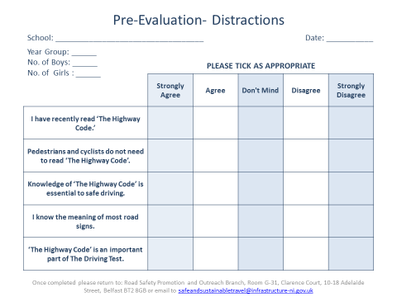
Annex A
ANNEX B
