**At the Scene of a Collision**

You will often hear car crashes referred to as an “accident” but it is a fact that over 95% of crashes where someone is killed or seriously injured are due to human error and in many cases could have been prevented. Throughout this programme we do not refer to an accident but collision or crash.

The chances of any individual being present at the scene of a road collision immediately after it has happened are much higher than is commonly imagined.

This module will guide students in the task of dealing with the scene of a collision in a calm and constructive way. Certain priorities must be brought into play after an initial assessment of the condition of those involved in the accident, and the needs of individual casualties should be met pending the arrival of the ambulance crew, who will then continue the car and attention that has been initiated by the volunteer helper.

At the scene of a collision most people will stand idly by, shocked or horrified, not knowing what to do. The three minutes immediately following a collision are critical. During that time an injured person’s chances of survival can be greatly enhanced. An individual who knows which actions to take at the scene, and is familiar with the priorities to be allocated, may save the life of a seriously injured crash victim, and provide first aid to others.

After completing this unit the students should:

 

* Know what to do on arrival at the scene of a collision, and be able to allocate priorities for action based upon the needs of the victims.
* Know how to protect the scene of an accident and to summon the emergency services.
* Know the immediate care required by casualties who are not breathing, unconscious or bleeding.

This unit is aimed at a 35-40 minute lesson. The teacher can use the task sheets as a follow up to the power point presentation as and when required. We have included a suggested time for each task, but this is purely a guideline.

The following resources are intended to help you deliver this unit.

* Baseline evaluation (5 mins) (ANNEX A)
* Power point presentation/discussion (20 mins)
* Task sheets (5 mins per task sheet)
* Post evaluation (5 mins) (ANNEX B)
* Useful web links

**Sample Answers to Task Sheets**

**Task Sheet 1**

In Case of a Collision

1. **Protect the collision scene**

**FIRST AND FOREMOST YOUR OWN SAFETY IS PARAMOUNT**

The aim is to prevent further injuries being caused by other vehicles colliding with those already involved.

Park any vehicle safely and legally to warn other road users. Switch on headlights and/or hazard warning lights.

Protect yourself – show fluorescent/reflective clothing. Do not wander about the road or stand on the road with your back to oncoming traffic. Warn other vehicles, giving priority to vehicles which would use the section of the carriageway where the collision occurred.

Place warning triangles at least 50 metres before the scene of the collision and on the same side of the road – then wave down oncoming vehicles (at night, using a torch).

1. **Summon emergency services**

Use a mobile phone, if available, to summon emergency services. If no mobile phone is available the next person at the scene of the collision should be sent to telephone details of the collision. At a telephone:

1. lift the receiver
2. Dial 999 ask for ambulance. Give the number you are calling from

(c) Give the following information to the Ambulance Service

*Exact location of the collision, number of persons injured, number of person trapped, whether there is any fire, spilled petrol etc, any other relevant details.*

1. **Make any vehicles safe**

Switch off the ignition.

Put hand break on – if not possible or ineffective, chock the wheels with stones or wood. Insist that nobody smokes. Should fire break out, try to tackle it with a fire extinguisher or smother it with a blanket, soil or sand. BUT DO NOT PUT YOURSELF IN DANGER.

1. **Attend to casualties**

First investigate any casualty who is quiet. First Aid priorities are:

1. Make sure the person is breathing properly. Remove any obstruction in the mouth- if necessary emergency resuscitation (only if formally trained)
2. Stop any bleeding- apply and maintain pressure over a severe wound- use a clean cloth, handkerchief or paper tissues to cover the wound.
3. Consciousness- Again check breathing, ensure the airway is clear, and place in the recovery position.

**Task Sheet 2**

**CALLING THE EMERGENCY SERVICES (999)**

Q1. Your response to the Emergency Services Operator:

1. Ambulance, fire service and police
2. Give the number of the call box that you are ringing from. If you are calling from a mobile phone the emergency services operator will be able to see your mobile phone number on caller display.
3. Telephone box beside the Knock Lights at the junction between the A20 and A55 (another way would be to provide a Sat Nav reference or as much information about the area as you can).

Q2. Ensure vehicles are made safe; attend to casualties – order of priorities. Breathing, Bleeding, Consciousness

Q3. Briefly and clearly explain to the ambulance crew or the Doctor the position and condition of any injured persons, and state what actions have been taken. Be ready to assist if requested by the Emergency Services.

**Task Sheet 2**

Q1. Ans C – Warn the oncoming traffic of the danger

Q2. Ans B – Breathing, bleeding, consciousness

Q3. Ans C – Reassure them

For further information for motorists involved in a collision on the road see <https://www.psni.police.uk/advice_information/know-what-to-do-landing/In_a_road_traffic_collision/>

For further information on basic first aid at the scene of a collision see <http://www.nhs.uk/conditions/Accidents-and-first-aid/Pages/Introduction.aspx>

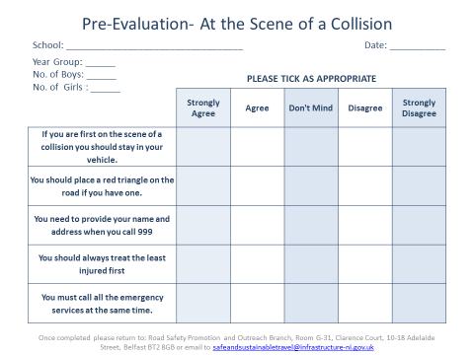

Annex A

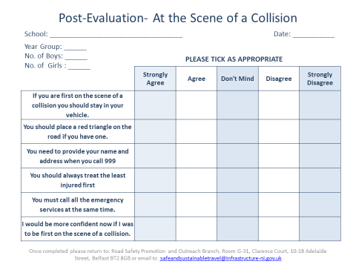

Annex B