Teacher Notes- Alcohol, Drugs and the Road User

It has long been recognised that drinking and drugs can be a serious problem amongst teenagers, and that the problems are compounded when linked with driving cars or riding motorcycles. Pedestrians too are endangered when suffering from the effects of alcohol/drugs, as road collision statistics clearly show. It is a matter of concern to note that the effects of alcohol/drugs are significant factors in road collisions involving young people.

The consequences for the young road user who takes to the roads after drinking/drug taking are too serious to be ignored, either in terms of death or serious injury, or loss of job and career opportunities following a drink/drugs/driving conviction.

After completing this unit the students should:

• Understand some of the social pressures which lead young people to drive after drinking.

• Know the possible consequences for the individual of being involved in a collision, in which alcohol/drugs were contributory factors.

• Be aware of the relative strengths of different sources of alcohol, and their effects on driving/riding performance.

This unit is aimed at a 35 -40 minute lesson. The teacher can use the task sheets as a follow up to the power point presentation as and when required. We have included a suggested time for each task, but this is purely a guideline.

The following resources are intended to help you deliver this Unit:

• Baseline evaluation (5 mins) (ANNEX A)
• Power point presentation/discussion (20 mins)
• Task sheets (5 min per task sheet)
• Post evaluation (5 mins) (ANNEX B)

Specimen Answers to Tasksheets

The answers given below are suggested rather than specimen answers and are provided as a guide to discussion points rather than as definitive statements. The DOE advertisement shows drinking as a social phenomenon, and highlights the consequences of irresponsible attitudes to drinking and driving.

Task Sheet 1

ALCOHOL

- How does alcohol affect your body?

Alcohol affects your brain which causes your thinking process and judgement skills to be impaired. It can also affect your moods making a person feel happy, depressed, emotional or anxious it can also give them a false sense of confidence. Physically alcohol can affect your ability to walk, talk, see, all of which can put you in danger. People do things when under the influence of alcohol that they would normally never consider doing while sober.

- Would you take a lift from someone who has been drinking alcohol?

The short answer to this is NO. If you know that someone has been drinking you should never travel in that vehicle as you are putting your life at risk. Discuss with your students what they would do if they found themselves in this situation. You should point out that they would be better using public transport, a taxi or ring a family member for a lift. Most parents will not mind coming out in the early hours if they know that their son or daughter is going to be safe. Discuss how this could be avoided by organising a lift at the beginning of the night. There should always be a designated driver who will only consume soft drinks throughout the evening.

- Is a drunk pedestrian less of a danger than a drunk driver?

NO. A drunk pedestrian will be in as much danger as a drunk driver. Anyone who is under the influence of drink does not have all their senses and will be in danger of walking into the road and being hit by a vehicle. Again you should discuss the importance of planning how to get home after a night out. Talk about the emotion to a family when someone doesn’t return home from a night out due to a road traffic collision that could have been avoided.

- What are the consequences if you kill or seriously injure someone while driving under the influence of alcohol?

Apart from the shame of taking a life you will face prosecution and a prison sentence. Talk about how this would impact on the student’s future.
Guilt
Shame – social stigma
Criminal Record
Unable to get a job
Banned from driving

Task Sheet 2

DRUGS

- How can drugs affect a person’s behaviour?

Different drugs can affect people in different ways depending on the category of drug taken. Stimulants such as cocaine, speed and ecstasy can make a person feel like they have lots of energy and confidence. Depressants such as alcohol, tranquillisers, heroin and cannabis can make a person feel chilled and relaxed. Hallucinogens such as magic mushrooms and LSD can make you view reality in a distorted way and cause vivid hallucinations. Some drugs may make people feel invincible, almost superhuman, making people take chances or make decisions they would normally never consider, putting themselves and others in dangerous situations. Any of these drugs will be detrimental to a road user.

- Is it always safe to drive while on prescription drugs?

NO. When taking prescription drugs you should always read the instructions or check with the GP. Some prescription drugs can cause drowsiness and affect how you drive, again putting the driver and others at risk.

- How would a pedestrian under the influence of drugs be at risk on the road?

Just like the pedestrian who has been drinking the person on drugs will not be in full control of their senses and could walk into the path of an oncoming vehicle causing themselves and others danger. Again, depending on the type of drug taken, the person may be overconfident and lead them to make dangerous decisions.

- How long do you think illegal drugs stay in your system?

Students may be surprised at how long some drugs actually remain in the body.
• Cannabis remains in your system for up to 6 weeks.
• Cocaine remains in your system for up to 3 days.
• Amphetamine substances (speed) can remain in your system for up to 4 days.

It is worth pointing out that many careers and sporting activities now carry out random drug tests, if drugs are detected in your system it could affect your potential career development.

Task Sheet 3

ROAD USERS

- Who do you think is responsible for most collisions on the road?

• Most collisions are caused by drivers aged between 17- 24;
• Men are responsible for 90% of alcohol related collisions;
• The numbers of women being detected drink driving are steadily increasing;
• 18-24 year old males are responsible for 2 out of 3 alcohol related collisions.

You may wish to discuss that these statistics will impact on higher insurance premiums for young people.

- Apart from drivers what other road users may be in danger if using drink or drugs?

• Pedestrians – a pedestrian who has been drinking or on drugs will not be in full control of their senses and could walk into the path of an oncoming vehicle causing themselves and others danger.
• Cyclists – anyone who takes drink or drugs and then cycles are putting themselves and others in grave danger. It is a criminal offence to be over the limit in charge of a bicycle.
• Motorcyclists – see above re cyclist; however a motorcycle has a lot more power and speed and has the potential to cause more damage.
• Passengers – anyone who chooses to travel with a driver under the influence of drugs or alcohol are putting themselves at great risk.

- Does society support drink/drug driving?

NO, there is a social stigma attached to drink/drug driving as there is just no excuse. It is a choice that people make. Ask your students how they would feel if a friend or family member were killed by a drink/drug driver.

- Would you have a criminal record if you are found to be over the legal limit?

Some students may not realise that drinking/drug driving is actually a criminal offence. They may view it as a minor misdemeanour. If caught drink/drug driving you will incur a large fine and lose your driving licence, should you kill or seriously injure someone as a result you will face prosecution and possibly be imprisoned. This will impact on your future potential for employment as you will have a criminal record which must be declared.
For further information on drugs see www.talktofrank.com
For information on current drink drive statistics see www.psni.police.u
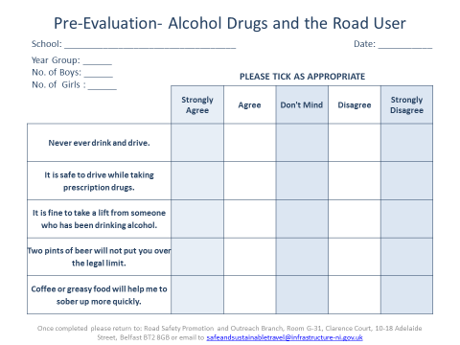
Annex A
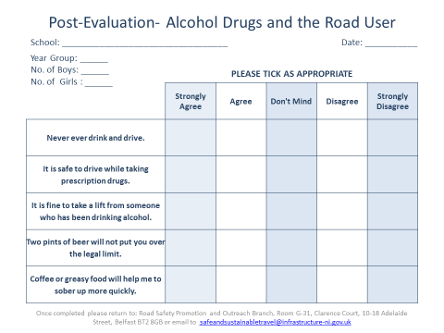
Annex B

