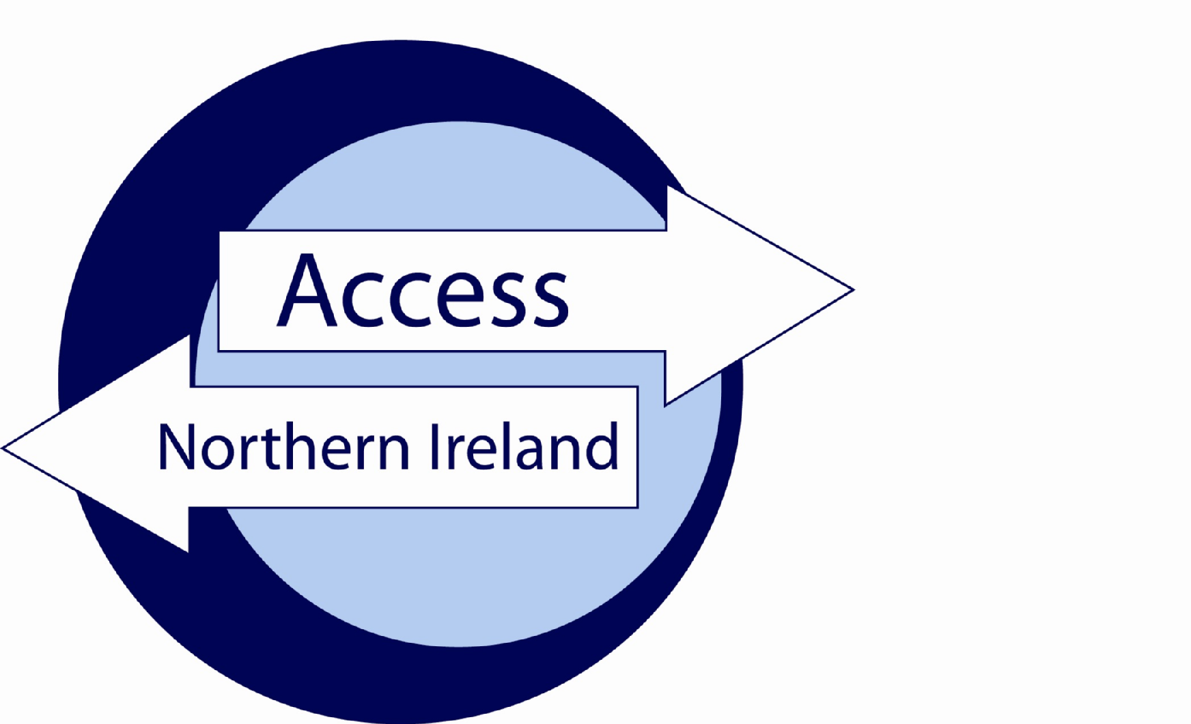

Service Level Agreement

Between

[Umbrella Body name]

(Responsible Body)

to process Basic Disclosure checks

and

*[3rd Party]*

Date [mm-yy]**Index**

**Page**

Section 1 – The Agreement 3

Introduction 3

Background 3

Scope 3

Assumptions 3

Section 2 – Roles & Responsibilities 4

Authorisation and agreement…………………………………………………………………………………….7

Annexe A…………………………………………………………………………………………………………...8

Annexe B…………………………………………………………………………………………………………...9

Annexe C………………………………………………………………………………………………………….10

# Section 1 – The Agreement

### Introduction

The purpose of this agreement between [Umbrella Body Name] and [3rd Party Name] is to set out the terms under which both parties will agree to comply when handling personal information during the AccessNI disclosure process.

This agreement is made on *[insert date]* and will commence at the same time.

Unless the Agreement is specifically amended, altered or withdrawn it will be automatically agreed to have rolled over on the 1st April each year.

### Background

Umbrella Bodies cannot take a recruitment decision on the basis of information contained on a Disclosure Certificate unless the applicant will be directly working for the Umbrella Body. This Agreement recognises thatAccessNI only provides a digital Disclosure Certificate to the applicant. However, the on-line case tracking system enables [Umbrella Body name] to know when a Disclosure Certificate has been issued and whether there is any information in that Certificate. [Umbrella Body name] will provide relevant information to [3rd party name]. [Umbrella Body name] will record details that their part of the process is complete.

### Scope

The terms of this agreement shall not be varied or amended unless agreed to and confirmed in writing by authorised representatives of [Umbrella Body Name] and *[3rd Party Name] or* AccessNI. AccessNI may, given appropriate notice, withdraw an organisations designation of Umbrella Body or request they do not offer their service to 3rd parties.

### Assumptions

This agreement is based on the following assumptions:

* An employer / organisation has approached the Umbrella Body to assist with the processing of an AccessNI disclosure application;
* The employer / organisation requires Basic disclosures for individuals who they may seek to recruit;Umbrella Body / employer will only submit applications to AccessNI using the on-line portal on the NI Direct website;
* Both parties to this SLA will have agreed the means by which payment for the Disclosure will be made, prior to submitting a disclosure to AccessNI;
* It is understood that AccessNI will only issue an invoice to the Umbrella Body;
* That the information supplied in Disclosure Application Forms is correct.

# Section 2 – Roles & Responsibilities

**Umbrella Body Name** will;

* assist [3rd Party Name] through the AccessNI Disclosure process, including providing the appropriate personal identification number (PIN) for applicants to enable them to use the on-line application process;
* ensure Disclosure Applications are countersigned properly;
* ensure identity documents uploaded to the AccessNI application by the applicant are listed on the [AccessNI list of acceptable identity documents](https://www.nidirect.gov.uk/sites/default/files/2025-06/List%20of%20acceptable%20ID%20documents%20-%20June%202025%20%281%29.PDF);
* reject identity documents provided by the applicant which are not acceptable to AccessNI;
* verify the information provided on the AccessNI application accurately reflects details on identity documents to include the provision of all middle names and/or previous surnames;
* be first point of contact with AccessNI on matters relating to Disclosure Applications submitted through them;
* gather any additional information AccessNI request by either directly contacting [3rd Party Name] or the applicant;
* notify [3rd Party Name] that
  + a Disclosure Certificate has been issued by AccessNI; and
  + there is no information on the Disclosure Certificate; or
  + information has been disclosed on the Disclosure Certificate. Where information has been disclosed the Umbrella Body should advise the employer to ask the applicant to share their digital Disclosure Certificate with them in order to view the information and progress to the next stage of the recruitment process.
* advise the employer/organisation to ensure that on sight of a Disclosure Certificate containing information they handle such information in line with the AccessNI Service Level Agreement and the Data Protection Act 2018;
* provide [3rd Party Name] with guidance on secure handling and storage of information;
* provide [3rd Party Name] with guidance on the recruitment of ex-offenders.
* provide[3rd Party Name]with a copy of the AccessNI Privacy Notice or provide a link ([*https://www.justice-ni.gov.uk/publications/ani-privacy*](https://www.justice-ni.gov.uk/publications/ani-privacy)*)*.
* monitor [3rd Party name] is complying with the Service Level Agreement.

**[*3rd Party Name*]** will;

* ensure that the appropriate PIN number is supplied to the applicant to complete the on-line application form;
* comply with the provisions set out in the Service Level Agreement;
* comply with provisions set out in this Service Level Agreement; ensure the information on Disclosure Certificates provided by applicants is retained in a secure manner, accessible only by those with authority to see them. Details of non-court convictions, convictions, police information or barred list information should not be retained after the recruitment decision is made;
* Ensure that the subject of a disclosure is aware that a Basic check (or re-check) is required for a position in the organisation.
* Retain signed documentary evidence (for the duration of the employment) that an applicant has agreed to undertake a Basic check;
* Obtain written permission from the individual applying for a Basic Disclosure if the certificate is to be delivered to the address of *[Name of Organisation].* Without such permission the Responsible/Umbrella Body will be in breach of the Data Protection Act (DPA) 2018;
* Have a written policy on the suitability of ex-offenders for employment in relevant positions that should not unfairly discriminate on the basis of conviction or other information disclosed. This policy should be available upon request to potential applicants and, in the case of those carrying out an umbrella function, should be made available to their clients.
* Either return original Disclosure Certificate to the Applicant or agree with the Applicant (in writing) the period for which the organisation will retain the original Certificate;
* Ensure that Disclosure information is not passed to persons not authorised to receive it;
* Ensure that Disclosure information is only made available to those who need to have access in the course of their duties;
* have a policy on the Secure Handling, Use, Storage and Retention of Disclosure information. This policy should be available upon request to potential applicants and, in the case of those carrying out an umbrella function, should be made available to their clients.
* If a paper application is being completed by the applicant provide the applicant with a copy of the AccessNI Privacy Notice or provide a link(<https://www.justice-ni.gov.uk/publications/ani-privacy>)to this document in your recruitment material.
* comply with recommendations made by the Umbrella Body.
* Issue all applicants with a copy of the Applicant Information Leaflet (as appropriately amended) at Annex B;
* Complete and return to the Umbrella Body the SLA checklist form (Annex C) along with a copy of your policy on

1. Recruitment of ex-offenders and
2. Secure handling, use, storage and retention of disclosure information.

# Section 3 – Authorisation and Agreement

The Services detailed in this Agreement have been authorised and agreed by the following parties

**PART A**

For [Umbrella Body Name]

Signed

Name

Position

Date

**PART B**

For [Name of 3rd Party]

Signed

Name

Position

Date

Annex A

|  |  |
| --- | --- |
| **PIN NOTIFICATION FORM FOR RESPONSIBLE BODIES**  **(Basic disclosure checks)** |  |

|  |  |  |
| --- | --- | --- |
|  |  |  |

**Applicant instructions**

1. Go to <https://www.nidirect.gov.uk/services/apply-online-basic-check-through-responsible-body>
2. Select the green button to create a nidirect account and apply for a basic check. If you already have a nidirect account you should use this. You may be prompted to uplift this account to a higher level – instructions will appear on screen. [Guidance document to create a nidirect account](https://www.nidirect.gov.uk/sites/default/files/2025-03/Guidance-document-to-creat-%20NID-%20LOA2-accoun-%20for-AccessN-%20applications-.PDF)
3. You will need to retain your login credentials for future use.
4. A digital identity validation will be conducted when you create or uplift the nidirect account. Your current name, DoB and current address will be verified by nidirect. You will be asked to upload the required identity documentation and provide a selfie. Instructions will appear on screen.

If there are problems creating this account contact nidirect **on 0300 200 7868** or email [nida@nidirect.gov.uk](mailto:nida@nidirect.gov.uk).

1. Once you have successfully created/logged in, you will be taken to the on-line AccessNI application.
2. Enter the PIN number below at Step 1 of the form completion.

|  |  |  |  |  |  |
| --- | --- | --- | --- | --- | --- |
|  |  |  |  |  |  |

1. Complete the remainder of the application.
2. Upload the required identity documents to the AccessNI application form. You are required to upload **two** identity documents, chosen from the [AccessNI list of acceptable identity documents](https://www.nidirect.gov.uk/sites/default/files/2025-06/List%20of%20acceptable%20ID%20documents%20-%20June%202025%20%281%29.PDF), to the AccessNI application form to allow the Signatory to verify that middle names and previous surnames have been provided. To help avoid delays, where possible the following documents should be uploaded with the application form:-

* Applicant’s birth certificate issued at time of birth or another suitable document that confirms the name(s) at birth and date of birth;
* A document that contains both the applicant’s current name and photograph.

1. Continue to complete the remaining fields on the application.
2. At STEP 12 you must confirm and date the declaration.
3. When you click on  **confirm and proceed**  the application will be automatically forwarded to the Signatory for approval.

|  |
| --- |
| **___________________________________________________________________________**  **Responsible/Umbrella Body Instructions to Applicant**  (INSERT FREETEXT) Example below.  Please provide name of your organisation__________________________________.  This information can be helpful to Umbrella Bodies when processing disclosure applications for several client organisations. |

**AnneAnnex B**



**AccessNI Disclosure – Applicant Information Leaflet**

As part of the recruitment process for a role in which you have expressed an interest, a criminal record check is required to be completed. In Northern Ireland this check is undertaken by AccessNI, upon receipt of a valid application. A disclosure certificate will be issued at the end of the process, including criminal record and other relevant information.

You can find out more about AccessNI on the nidirect website, or at the following link:-

[AccessNI webpage](https://www.nidirect.gov.uk/campaigns/accessni-criminal-record-checks)

The AccessNI application must be made on-line through the nidirect website. You will be required to set up a nidirect account to complete your application. The application will be checked and authorised by an approved Umbrella Body before being transferred to AccessNI for processing. A link to the AccessNI Privacy Notice is available [here](https://www.justice-ni.gov.uk/sites/default/files/publications/justice/accessni-revised-privacy-notice-3-May-2018.pdf) or prior to commencing the e-application form.

You should note the following important information about the AccessNI application process:-

1. [Name of Umbrella Body] has been appointed to check and authorise your application.
2. The name of the authoriser is [Name of Signatory].
3. The PIN to be used on the on-line application is [XXXXXX].
4. You will be requested to upload two relevant identity documents to the application, these will be destroyed 90 days after the date the disclosure certificate is issued, in line with the AccessNI retention policy.
5. Your employer, and not the Umbrella Body, will be responsible for the decision whether or not to offer you a position.
6. Having a criminal record does not necessarily prevent you from obtaining a position.
7. A policy is in place that sets out the organisation’s approach to recruiting ex-offenders – a copy of this can be made available at your request.

If you have any questions in relation to this process you should, in the first instance, contact the person who asked you to complete the AccessNI application.

**Annex C**

**Service Level Agreement – Checklist**

In order to evidence compliance with the provisions within the Service Level Agreement, this form should be completed by [Name of Client Organisation] and returned to [Name of UB] along with the signed SLA and copy documentation as indicated below.

I confirm that [Name of Client Organisation] will:-

|  |  |  |  |
| --- | --- | --- | --- |
| **Requirement** | | **Yes** | **No** |
| 1 | Ensure that all applicants for relevant positions are notified in advance of the requirement for a Basic AccessNI check. |  |  |
| 2 | Comply with provisions in Data Protection Act 2018, and will not retain disclosure information for any longer than is required for the specific purpose. |  |  |
| 3 | Notify all potential applicants of the possible effect of a criminal record on the recruitment and selection process, and any recruitment decision. |  |  |
| 4 | Discuss any matters revealed in disclosure information with the person seeking the position before withdrawing an offer of employment. |  |  |

I further confirm that [Name of Client Organisation] has the following policy documents in place, and that copies of same have been provided to [Name of Umbrella Body]:-

|  |  |  |  |
| --- | --- | --- | --- |
| **Requirement** | | **Yes** | **No** |
| 1 | Policy on recruitment of ex-offenders. |  |  |
| 2 | Policy on secure handling, use, storage and retention of disclosure information |  |  |

**To be signed by representative of Client Organisation.**

|  |  |
| --- | --- |
| Signed: ……………………………...……………… | Date: …………………… |
| Print Name: ………………………………………… |  |