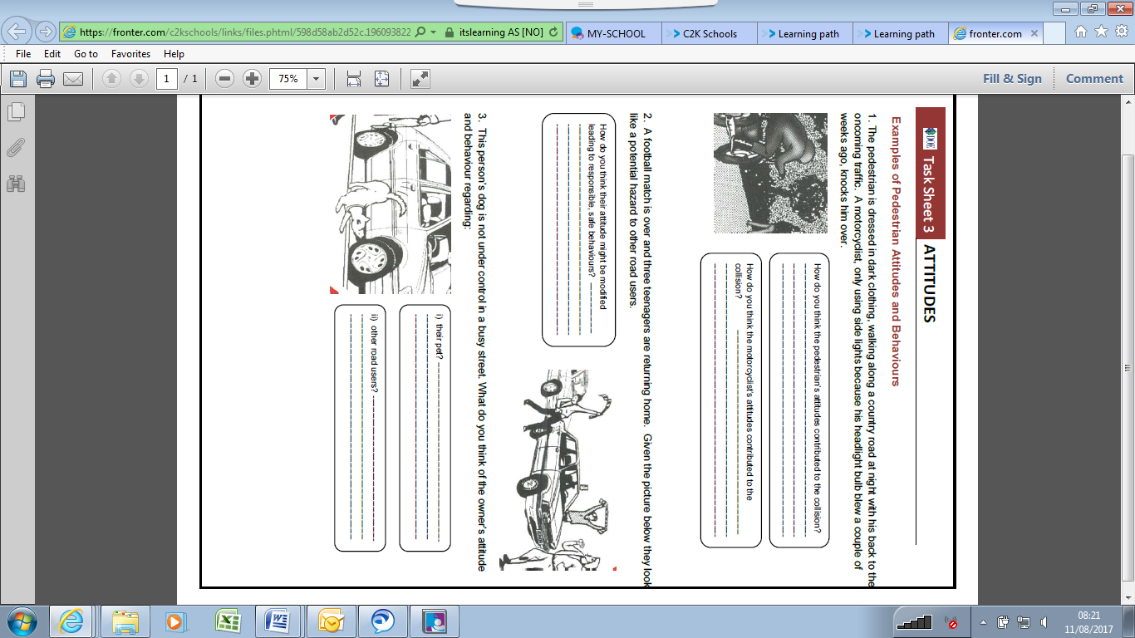

**Task Sheet 3 – Attitudes**