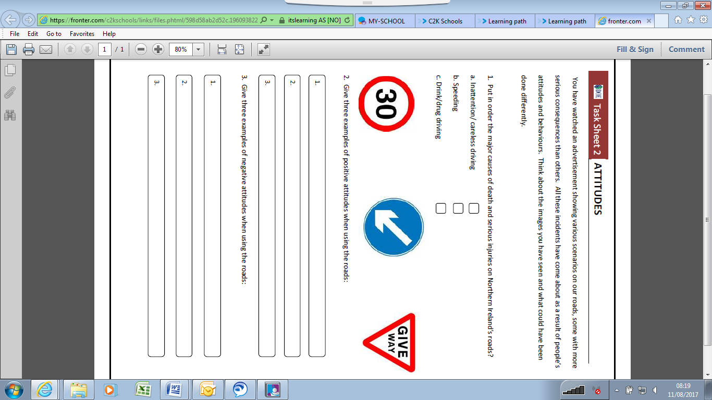

**Task Sheet 2 – Attitudes**